Pressemelding AIR Træna (engelsk)
TOP TEN artists from all around the globe are ready for AIR Træna!

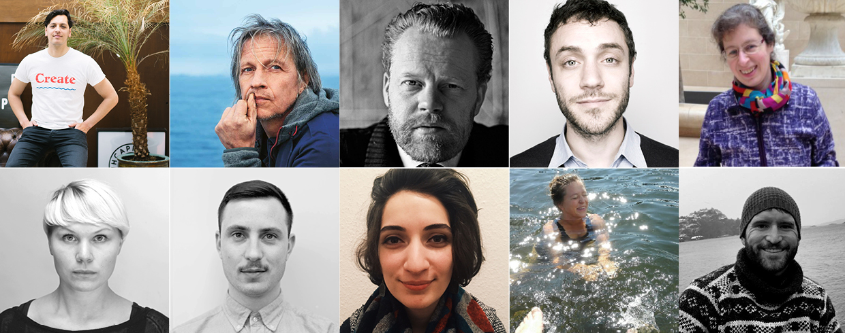

Træna an international melting pot! Records were broken when more than 60 people applied for this year of Artists in Residence. Out of those have now ten people been hand-chosen. The jury had a hard time selecting between creative minds from every corner of the world. The lucky ten will be coming to Træna during different time periods in 2016. Among others we will see swedish musician Stefan Sundström and New York-based designer Eric Forman.

Granted projects 2016:
- Solveig Nygaard Langvad (Norway) winter-bathing journalist who will publish a book about bathing. (February/March)
- Esli Tapilatu, (The Netherlands) graphic designer and social entrepeneur. He creates positive campaigns and will publish the magazine Capital of Happiness. (April)
- Stefan Sundstrøm (Sweden) artist, chronicler and author. Will write a book about the districts, and how central in fact lay in the margins. (May)
- Marianne Bjørnmyr & Dan Mariner (London/Bodø) Will make a book about salt. (May)
- Arusyak Manvelyan (Berlin/Armenia) Architect who will build an outdoor community venue. (July) Lars Erik Skimten (Lindesnes) free-diver who will co-operate with a nature photographer and a tourist guide from Svalbard about developing a concept around diving-tourism in Træna. (july)
- Eric Forman (New York) Head of Innovation, School of Visual Arts. Will make an interactive installation, with sculpture and video. (August)
- Consuelo Griggio (Canada/Gotland) Island researchers who wish to examine tourism and authentic island-communities around the polar circle. (September)
- Ole Brodersen, (Oslo/Lyngør) art director/photographer who will create the analog photo project Trespassing Træna. (October)
Besides these will also the swedish architects Hilda Hallén & Maja Hallén, actually from last years AIR, finalize the project of restoring Trænas oldest a boat-house this summer.

More information
Moa Björnson
AIR Træna
(+47)47478016
moa@trana.kommune.no

Jury: Marit Bertheussen, Træna museum, Moa Björnson, Tenk Træna, Anita Overelv, Hamsund center, Lill Dahn, Havfolkets Hus, Erling Ribe Ramskjell, musician, Thore Hopperstad, Træna municipality, Jill Lyngsø, singer, Lovund

Material for publishing, download press photos and contact information of the artists: https://www.dropbox.com/sh/u6396tmk8hkh6q5/AACSClPk9eiuYvPoo3PEKabwa?dl=0

